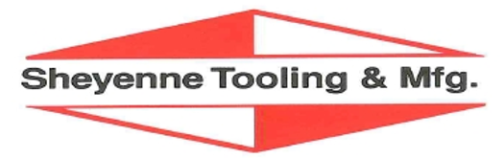

Job Description – Key Accounts Manager
Reports to: President

Location: Cooperstown, ND (Preferred)

Overview:
Be a part of a growing and family-owned company at Sheyenne Tooling & Mfg.!

Sheyenne Tooling & Manufacturing designs and manufactures a diverse range of Agricultural & Construction supporting products. In addition to selling and distributing our own products, Sheyenne Tooling & Mfg partners with other key manufacturers to support their manufacturing needs. We have an immediate opening for a Key Accounts Manager interested in developing trusted relationships with our top customers. Primary responsibility includes maintaining customer relationships by understanding their requirements and translating them into results.

Build a career with Sheyenne Tooling & Mfg by working directly with business leadership and executing plans providing tangible and visual results. Account manager experience is preferred, but being self-motivated along with a “team mentality” and providing customer satisfaction is required.

General Duties:
- Interface effectively with cross functional team members to ensure success
- Communicate effectively with top customer (in person, phone, email and online)
- Gain in-depth knowledge of customer products, needs and expectations
- Lead process improvement initiatives aimed at seamless customer interaction
- Manage and develop account specialist team

Position Requirements:
- Experience in a manufacturing environment
- Microsoft Office knowledge required. Advanced Excel skillset preferred
- Analytical and strategic thinking
- Excellent communication and collaboration skills
- Grasps technology to enable productive processes
- Bachelor’s degree in Business Management or similar

Preferred Skills/Background:
- Knowledge of manufacturing processes
- Experience with an ERP system
- Collaboration experience with SharePoint
- 3+ years’ experience preferred

Benefits of joining the Sheyenne Tooling & Mfg Team:
- Competitive Pay and Benefits
- Collaborate with all levels of the organization
- The Key Accounts Manager will be a Cooperstown based position offering remote flexibility

Sheyenne Tooling & Mfg is an Equal Opportunity Employer. Sheyenne Tooling & Mfg does not discriminate on the basis of race, religion, color, sex, gender identity, sexual orientation, age, non-disqualifying physical or mental disability, national origin, veteran status or any other basis covered by appropriate law. All employment is decided on the basis of qualifications, merit, and business need.

